Parent Homework in Focus due by August 18, 2024

EVERY family must complete these steps for EVERY child

If you do not have a parent FOCUS account, start at step 1.

If you already have a parent FOCUS account ***BUT*** you don’t know your username, ***DO NOT*** create another account. Please go to [Parent Account Registration](https://focus.pcsb.org/focus/auth/?lang=en) and choose Box C: RESET my Password.

If you can get logged into your parent FOCUS account ***AND*** you can see your child’s grades in Focus, skip to step 6. If you ***CAN'T*** see your children, start at step 4.

Steps:

1. Go to [focus.pcsb.org](https://focus.pcsb.org/focus/index.php)
2. Click on the green box that says, “Create a Focus Parent Portal Account” A green and white sign

   Description automatically generatedto create your account.
3. Go back to [focus.pcsb.org](https://focus.pcsb.org/focus/index.php) BUT do not log in.
4. Click on the green box that says, “Link a Student to Your Focus Parent Portal Account” A green sign with white text

   Description automatically generated. You will need to link ***all*** your children attending Pinellas County Schools.
5. Log out
6. Log back into focus.pcsb.org
7. Now you will upload or take a photo of your government issued ID.
   1. ***If you are doing this on a computer,*** 
      1. you will see your children on the left side of the screen. Click on “My Profile” A screenshot of a social media account

         Description automatically generated.
      2. Click on “General” 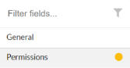
      3. Hover the mouse over the box above the words “Government Issued Photo ID” A close-up of a computer screen

         Description automatically generatedand select how you would like to submit your ID.
   2. ***If you are doing this on a cell phone,***
      1. Click on the hamburger lines 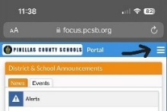.
      2. Click on “My Profile” 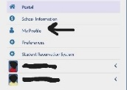
      3. Click on the blue arrow to open the left side panel. 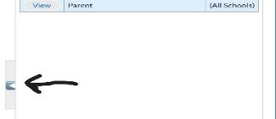
      4. Click on “General” 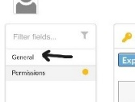
      5. Click in the empty box for the “Government Issued…” and take a photo of your ID 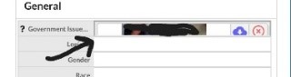
8. Log out of Focus
9. Send an email to BOTH [parecelm@pcsb.org](mailto:parecelm@pcsb.org) AND [hammocko@pcsb.org](mailto:hammocko@pcsb.org) stating your child/children’s name and that you have “uploaded your ID in Focus”. They will then approve your submission.
10. It may take a while for the approval to come through due to the vast number of families doing this same process, so please be patient!
11. Log into Focus again after 24-48 hours.
12. Once you have been approved, you will see your child/children’s name and 2 green boxes per child.
13. Click on EACH green box to complete the required information.
14. In the section about Technology Acceptance and Responsibility, you must select “I authorize my student to accept delivery...” for your child to be able to borrow or continue to borrow a school laptop for this school year.

If you still need assistance, please email [wolfech@pcsb.org](mailto:wolfech@pcsb.org)